Leet Code DP
This paper will cover some LeetCode Dynamic Programming.

Top Down or Bottom up
In some type of Dynamic Programming problem we can do from top to bottom or from bottom to top. The traditional DP is from bottom to top, with the distance between start node and end node slowly growing.
If we do top to bottom we can consider the problem as divide and conquer, with the recursive function all.
Let’s see the following example:
1039. Minimum Score Triangulation of Polygon
Medium
Given N, consider a convex N-sided polygon with vertices labelled A[0], A[i], ..., A[N-1] in clockwise order.
Suppose you triangulate the polygon into N-2 triangles. For each triangle, the value of that triangle is the product of the labels of the vertices, and the total score of the triangulation is the sum of these values over all N-2 triangles in the triangulation.
Return the smallest possible total score that you can achieve with some triangulation of the polygon.

Example 1:
Input: [1,2,3]
Output: 6
Explanation: The polygon is already triangulated, and the score of the only triangle is 6.
Example 2:
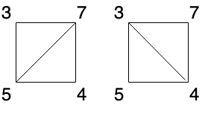
Input: [3,7,4,5]
Output: 144
Explanation: There are two triangulations, with possible scores: 3*7*5 + 4*5*7 = 245, or 3*4*5 + 3*4*7 = 144. The minimum score is 144.
Example 3:
Input: [1,3,1,4,1,5]
Output: 13
Explanation: The minimum score triangulation has score 1*1*3 + 1*1*4 + 1*1*5 + 1*1*1 = 13.

Note:
- 3 <= A.length <= 50
- 1 <= A[i] <= 100
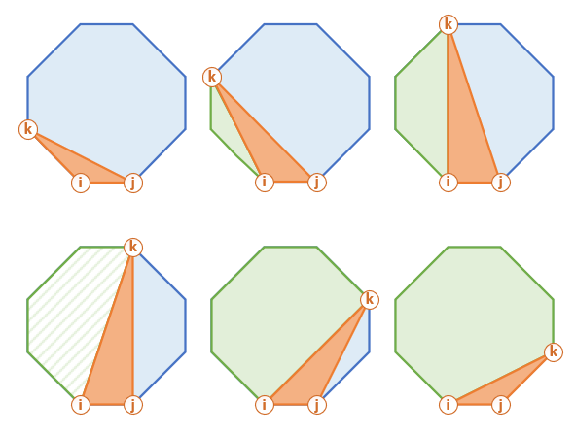
This is how this procedure looks for a sub-polygon (filled with diagonal pattern above).
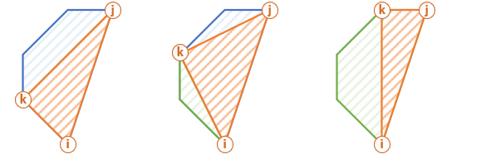

Top-Down Solution
• Fix one side of the polygon i, j and move k within (i, j).
• Calculate score of the i, k, j "orange" triangle.
• Add the score of the "green" polygon i, k using recursion.
• Add the score of the "blue" polygon k, j using recursion.
• Use memoisation to remember minimum scores for each sub-polygons.

int LeetCode::minScoreTriangulation(vector<int>& A, int start, int end, unordered_map<string, int>& cache)
{
if (end - start < 2) return 0;
string key = to_string(start) + "," + to_string(end);
if (cache.count(key) > 0) return cache[key];
int result = INT_MAX;
for (int middle = start + 1; middle < end; middle++)
{
int sum = minScoreTriangulation(A, start, middle, cache);
sum += A[start] * A[middle] * A[end];
sum += minScoreTriangulation(A, middle, end, cache);
result = min(result, sum);
}
cache[key] = result;
return result;
}

int LeetCode::minScoreTriangulation(vector<int>& A)
{
unordered_map<string, int> cache;

return minScoreTriangulation(A, 0, A.size() - 1, cache);
}

int LeetCode::minScoreTriangulationII(vector<int>& A)
{
vector<vector<int>> dp(A.size(), vector<int>(A.size()));
for (size_t k = 2; k < A.size(); k++)
{
for (size_t i = 0; i < A.size(); i++)
{
size_t j = i + k;
if (j >= A.size()) break;
for (size_t m = i + 1; m < j; m++)
{
if (dp[i][j] == 0)
{
dp[i][j] = dp[i][m] + A[i] * A[m] * A[j] + dp[m][j];
}
else
{
dp[i][j] = min(dp[i][j], dp[i][m] + A[i] * A[m] * A[j] + dp[m][j]);
}
}
}
}
return dp[0][A.size() - 1];
}

Longest Common Subsequence
1035. Uncrossed Lines
Medium
1325FavoriteShare
We write the integers of A and B (in the order they are given) on two separate horizontal lines.
Now, we may draw connecting lines: a straight line connecting two numbers A[i] and B[j] such that:
- A[i] == B[j];
- The line we draw does not intersect any other connecting (non-horizontal) line.
Note that a connecting lines cannot intersect even at the endpoints: each number can only belong to one connecting line.
Return the maximum number of connecting lines we can draw in this way.

Example 1:
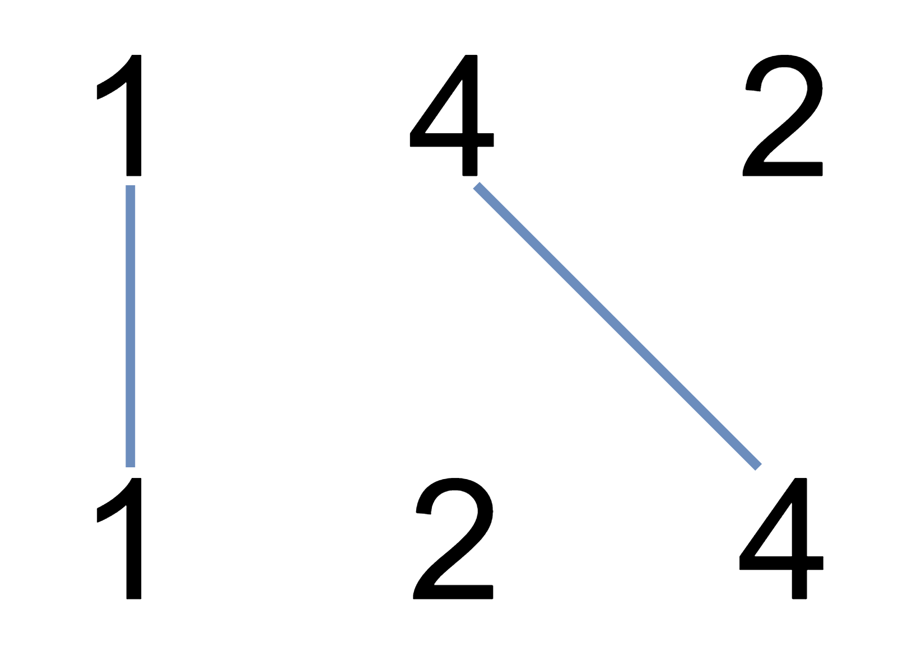
Input: A = [1,4,2], B = [1,2,4]
Output: 2
Explanation: We can draw 2 uncrossed lines as in the diagram.
We cannot draw 3 uncrossed lines, because the line from A[1]=4 to B[2]=4 will intersect the line from A[2]=2 to B[1]=2.
Example 2:
Input: A = [2,5,1,2,5], B = [10,5,2,1,5,2]
Output: 3
Example 3:
Input: A = [1,3,7,1,7,5], B = [1,9,2,5,1]
Output: 2

Note:
- 1 <= A.length <= 500
- 1 <= B.length <= 500
- 1 <= A[i], B[i] <= 2000
This problem can be regarded as a longest common sequence, so map to the string comparison algorithm in DP.
We compare two string with comparing each character based on their sequence. If two characters are same we take the left-up corner number and add one, otherwise we choose the maximum of upper side or left side.
 | 10 | 5 | 2 | 1 | 5 | 2
2 | 0 | 0 | 1 | 1 | 1 | 1
5 | 0 | 1 | 1 | 1 | 2 | 2
1 | 0 | 1 | 1 | 2 | 2 | 2
2 | 0 | 1 | 2 | 2 | 2 | 3
5 | 0 | 1 | 2 | 2 | 3 | 3

int LeetCode::maxUncrossedLines(vector<int>& A, vector<int>& B)
{
vector<vector<int>> dp(A.size() + 1, vector<int>(B.size() + 1));
dp[0][0] = 0;
for (size_t i = 0; i < A.size(); i++)
{
for (size_t j = 0; j < B.size(); j++)
{
dp[i + 1][j + 1] = max(dp[i][j + 1], dp[i + 1][j]);
if (A[i] == B[j]) dp[i + 1][j + 1] = max(dp[i + 1][j+1], dp[i][j] + 1);
}
}
return dp[A.size()][B.size()];
}

DP with many choices
When we think DP in a continus array, normally we should think from the point with any index, and only look the subarray before this point, and see how may option we should collect the data and record them.
For example, in the following problem on any index in the array, we can see the partition ending with current index as 1, 2, 3, … K
1043. Partition Array for Maximum Sum
Medium
11710FavoriteShare
Given an integer array A, you partition the array into (contiguous) subarrays of length at most K. After partitioning, each subarray has their values changed to become the maximum value of that subarray.
Return the largest sum of the given array after partitioning.

Example 1:
Input: A = [1,15,7,9,2,5,10], K = 3
Output: 84
Explanation: A becomes [15,15,15,9,10,10,10]

Note:
- 1 <= K <= A.length <= 500
- 0 <= A[i] <= 10^6
int LeetCode::maxSumAfterPartitioning(vector<int>& A, int K)
{
vector<int> result(A.size());
vector<int> dp(A.size());
for (int i = 0; i < (int)A.size(); i++)
{
dp[i] = A[i];
for (int j = 0; j < K; j++)
{
int first = i - j;
if (first < 0) break;
dp[i] = max(dp[i], A[first]);
int prev = first - 1;
if (prev < 0)
{
result[i] = max(result[i], dp[i] * (j + 1));
}
else
{
result[i] = max(result[i], result[prev] + dp[i] * (j + 1));
}
}
}
return result[result.size() - 1];
}

